Participant– Jenn

Scenario #3
Task #1

- The user tapped the “support” control to see what is available.
Recommendation: The user felt that if there are a variety of supports she would recommend placing it in the center of the screen or more noticeable location as this seems to be the purpose of the app. Also she would want it to be the focal point so it was easy to locate.

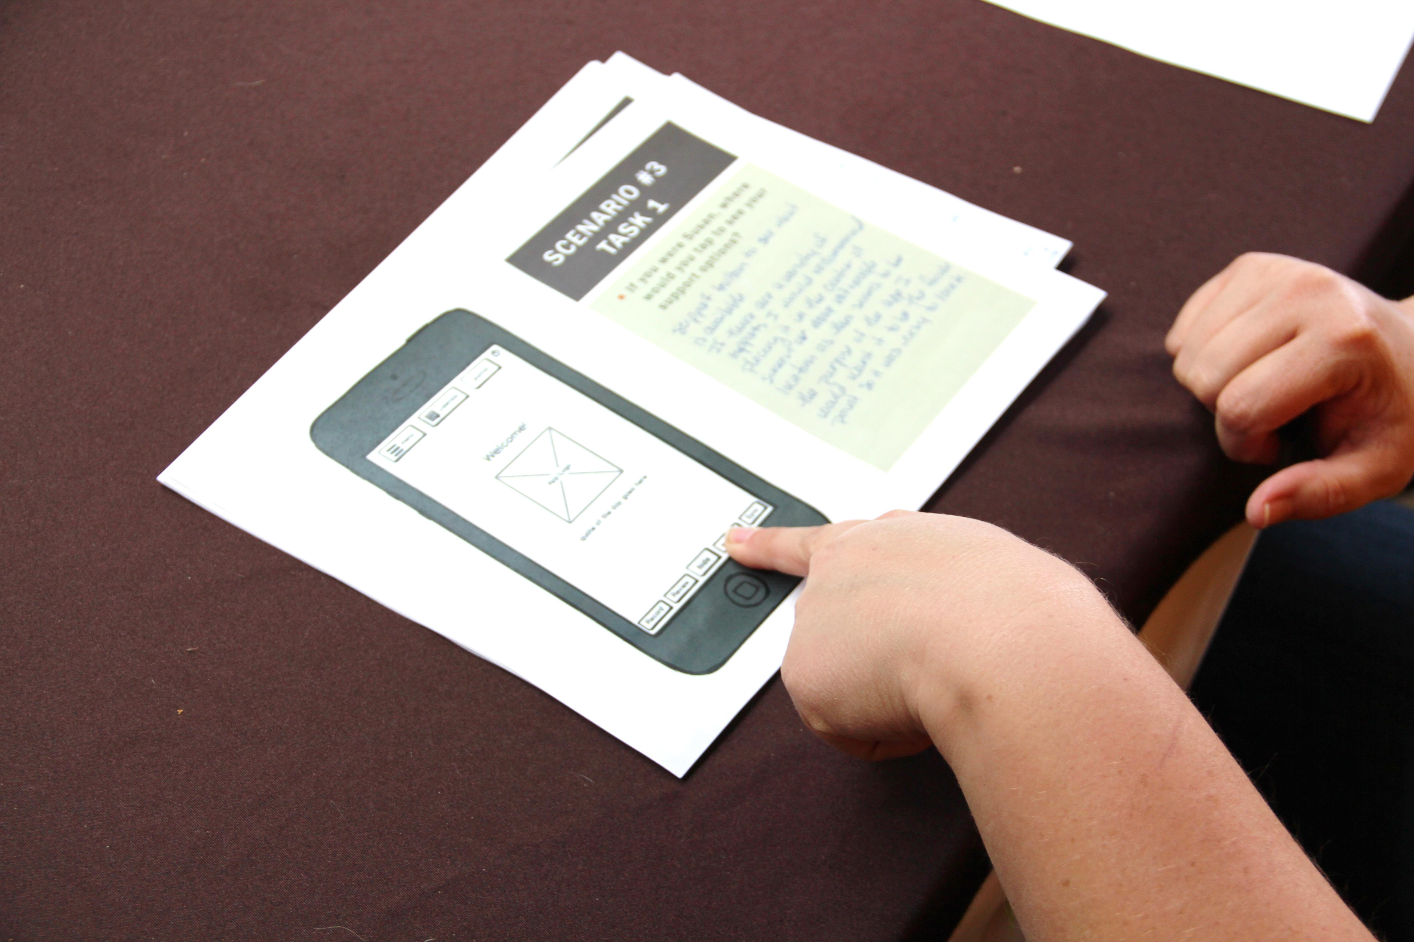

What resources would you expect to find under “General Resources?”
- links to resources like:
  - therapy groups/support
  - doctors
  - people I could speak with (regular people- not doctors)
  - medication that might support my situation so I could make an informed decision if I chose that route
  - hot line/crisis/talk numbers
  - links to medical health providers & descriptions of mental health issues (define depression, anxiety, schizophrenia etc.)
- If I didn’t want to see someone for help I’d research & try to figure out what was wrong to help my solve problem myself.
THINGS I could try to improve my situation: meds, exercise, diet, journaling, etc.
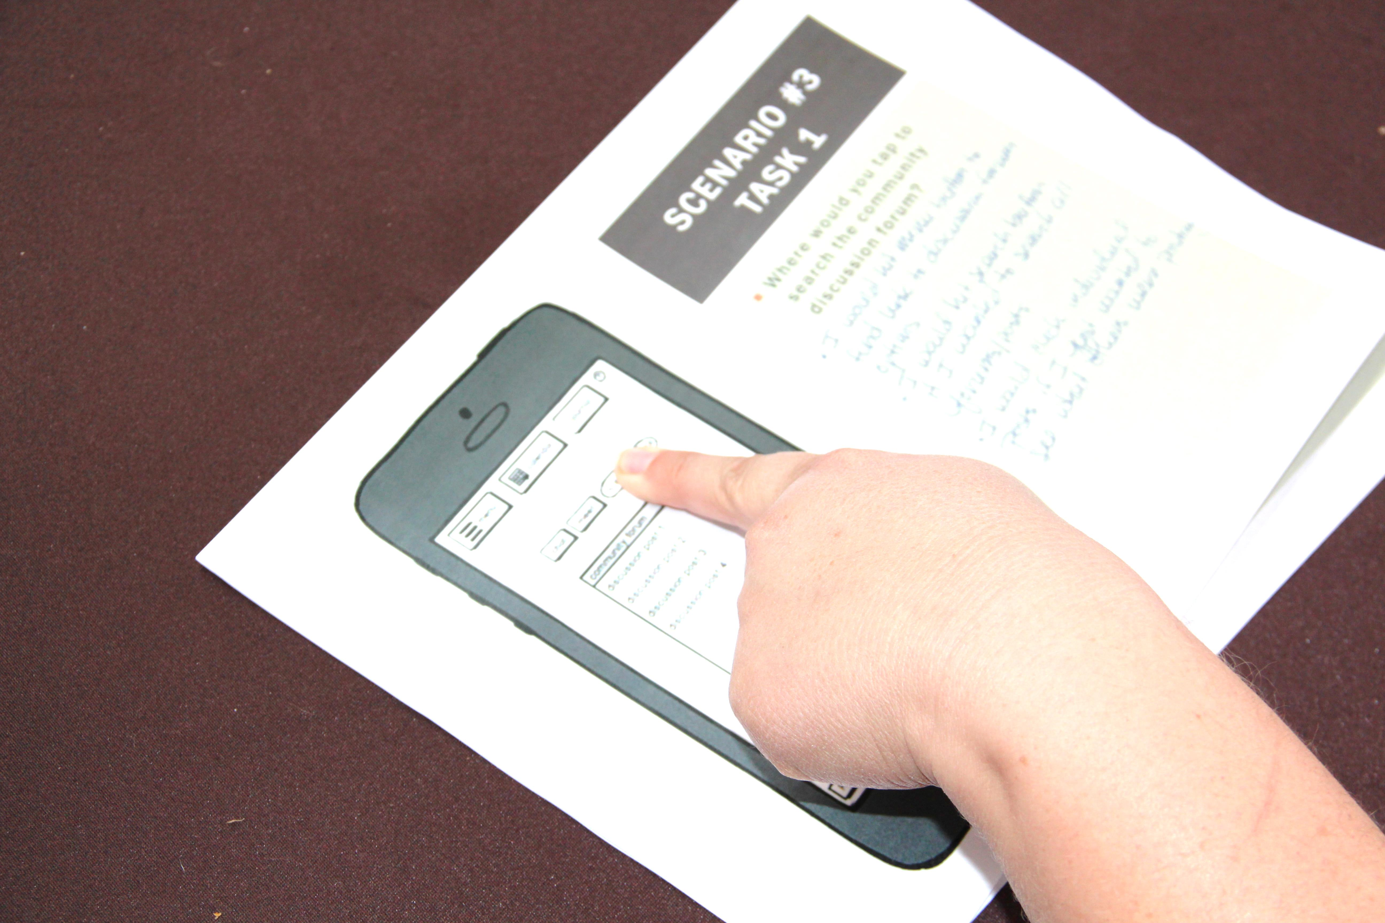

Where would you tap to search the community discussion forum?
- I would hit the menu control to find links to discussion forum options.
- I would hit the search control of I wanted to seach all forums/posts
- I would click the indivdual posts if I just wanted to see what others were posting.

Is the community forum the first thing you would expect to see after selecting “College Support Network?”
No- I would expect to see options within the college network. I would expect there would be something other than the discussion posts: s uch as: chat, meet, support groups , mental health professionals on campuses, etc.

Scenario #3
Task #2

- The user tapped “the chat” control
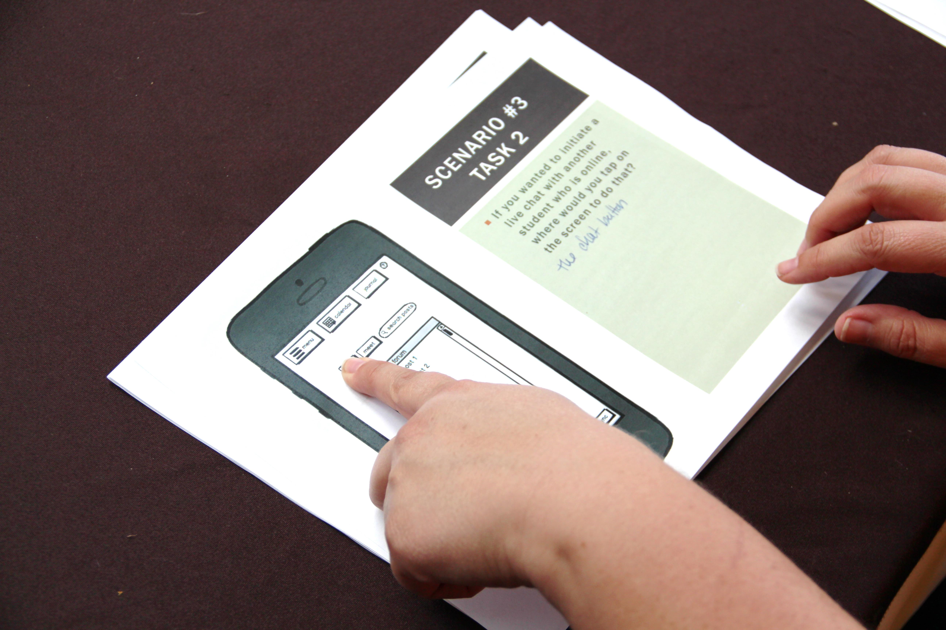

Would you feel comfortable chatting online with another college student anonymously regarding such issues?
Yes- anonymity would give me the space and confidence to be honest with another person about what was going on without fear of judgment, persecution, losing control of who knew , etc.

Scenario #3
Task #3

- The user tapped the “meet” control

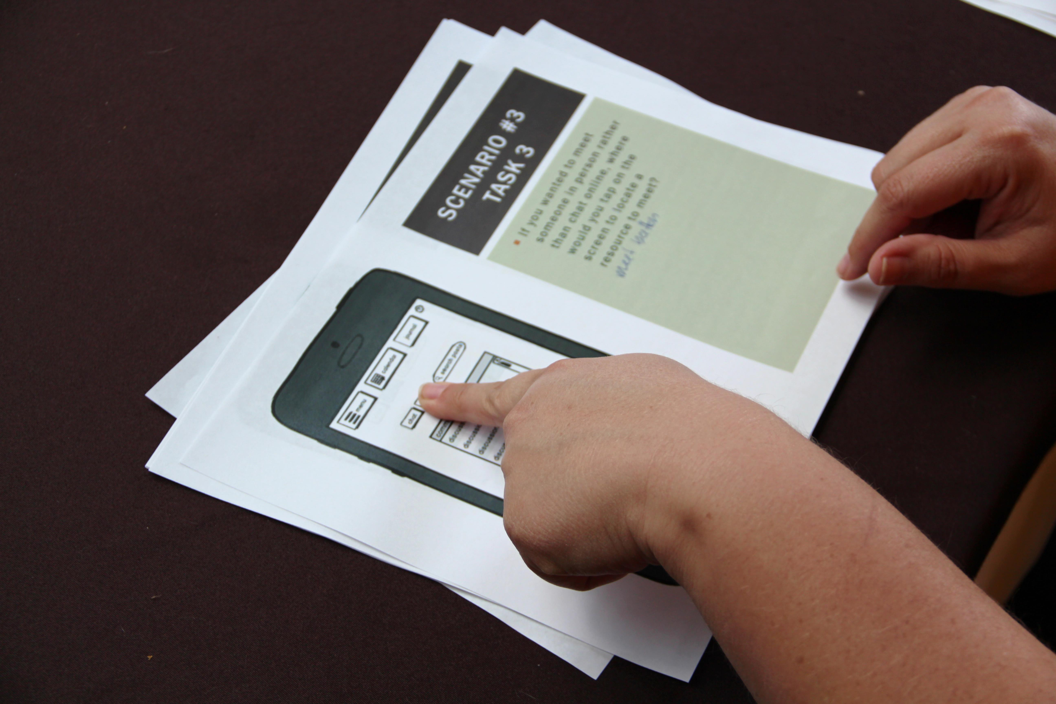

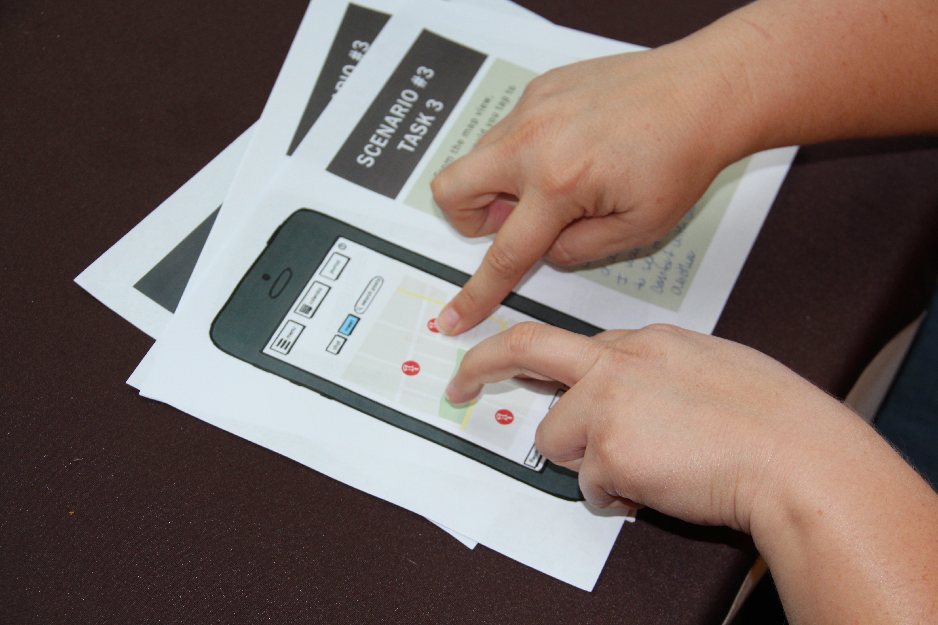
From the map view, where would you tap to see the personal contact information for the available resources?

- The user would tap the location on the map that was closest to where I was interested in meeting and/or tap each one to see if there was a description of the individual I would meet at each location to see if I felt a connection/comfort with one person over another.
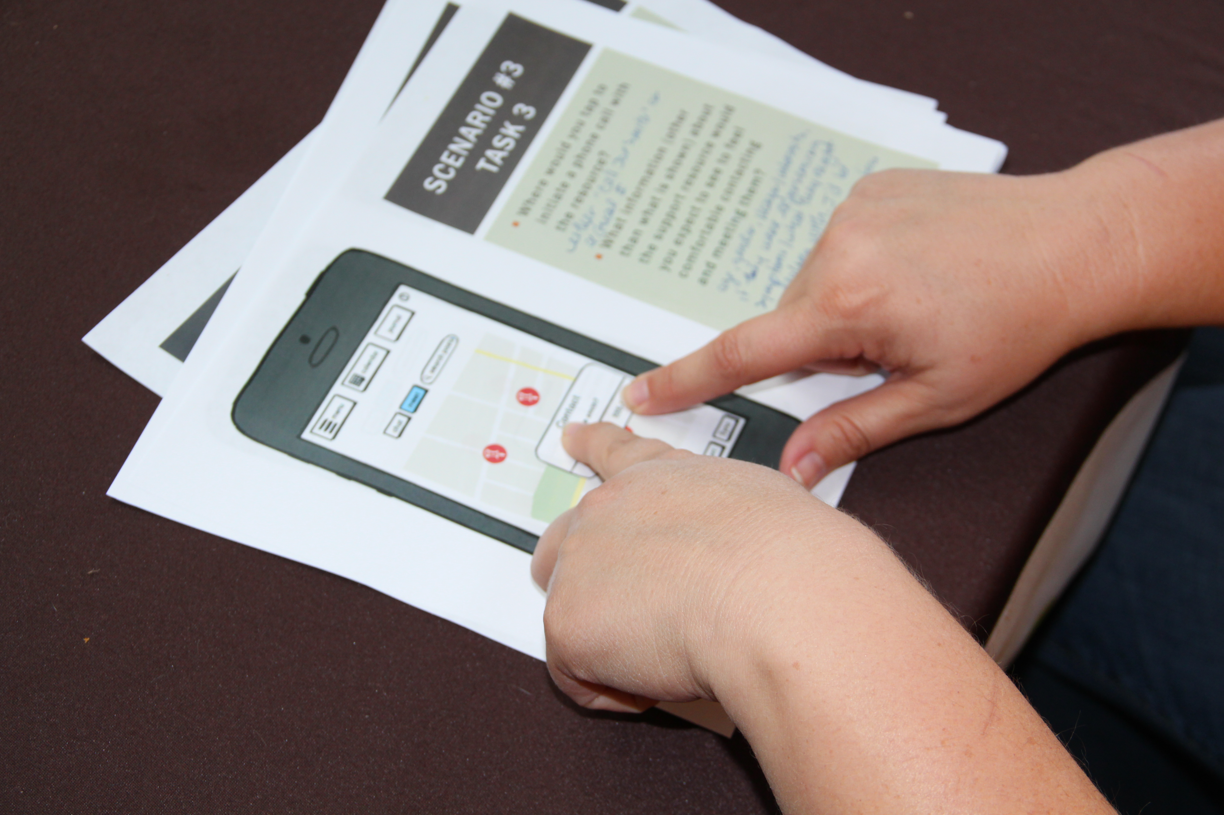
“Where would you tap to initiate a phone call with the resource?”
- The user would either tap “call Joe Smith” or the actual number.

“What information about the support resource would you expect to see to feel comfortable contacting and meeting them?
- Age, gender, maybe interests, if they were experiencing symptoms/what they might be dealing with. I’d be looking to feel a connection with the person.

Scenario #3
Task #4
- The user tapped either “support” or “menu” control

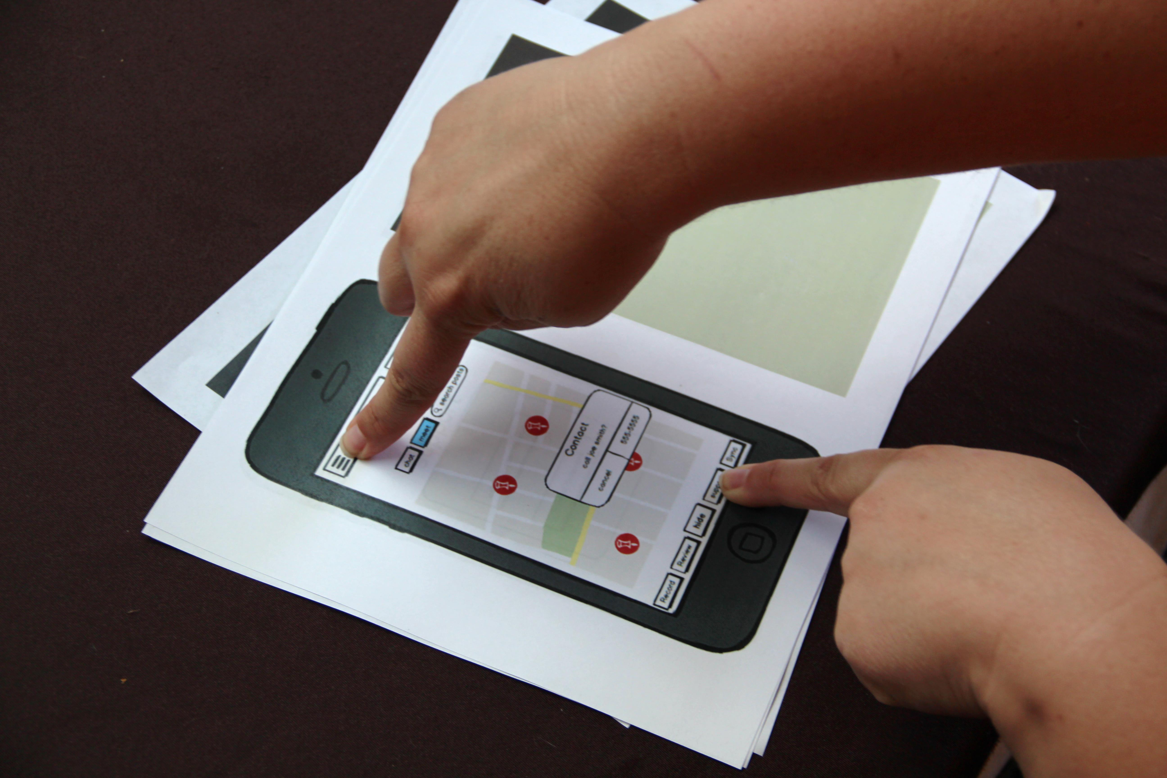

“From the main Support screen, where would you tap to find information from resources like NIH or NAMI (non-college specific resources)?
- User tapped general resources control
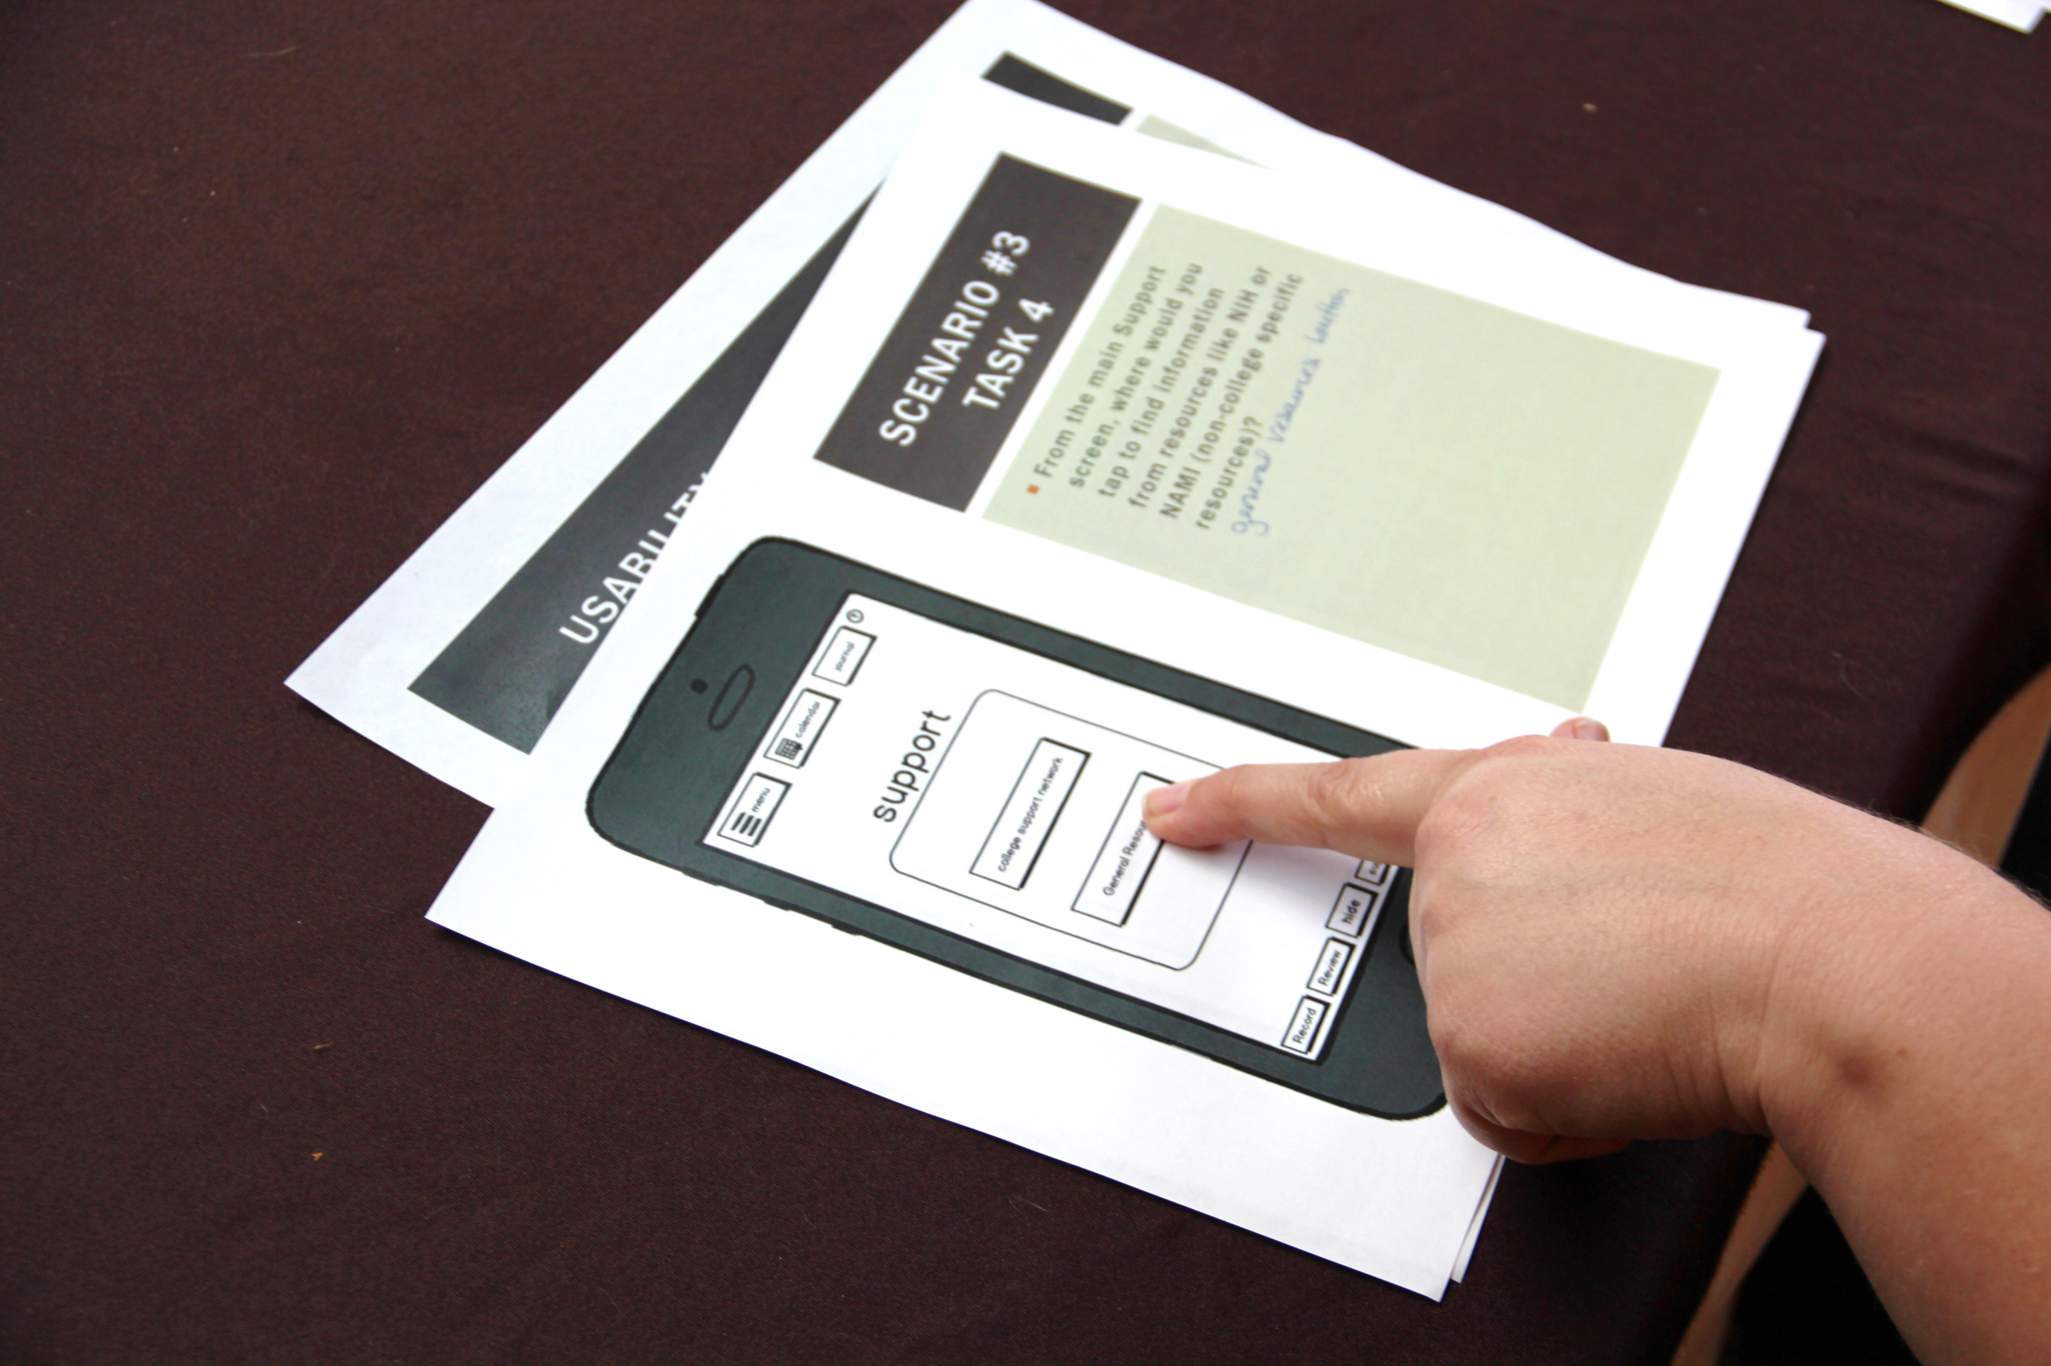

Is “General Resources” a good name for the non-college specific resources available through the app?

- User would suggest “Other Resources” to denote they were not college affiliated

